Hockinson High School Band Formal Fashions, Inc.
Concert Attire Order Information www.formalfashionsinc.com
1-800-528-7909 M-F 8AM -4PM

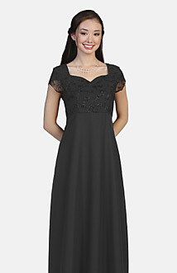 Black Concert Gown $69.00 + $15.00 shipping
$69 - Style 4966TC Glitter Flocked Velvet Overlay/Crepe Back Satin
Empire style gown featuring a “sweetheart” neckline and “chiffon” tulip sleeves. Shown with a velvet flocked chiffon with glitter bodice and crepe back satin skirt with E-Z FIT sash ties to create a perfect waistline every time.
Available in virtually every size!
Misses sizes 00 - 34.
Children sizes 05 - 13.
PLEASE MEASURE. Guessing may result in additional expense due to restocking and additional shipping fees.
Please order the gown by August 31st to allow for shipping and hemming before our first concert.

A garment bag is suggested to protect the gown for travel. Any garment bag is acceptable.

Formal Fashions sells a Heavy duty 65” Nylon dress bag: Item #1055 $12.00. Features include an ID window, accessory pouch and full-length zipper for easy access.

Mr. Formal

Students Name:__________________________________________

Address:_________________________________________

City:_______________________ St:_________________ Zip:________________________

Contact Email:_______________________________

Phone:________________________________ Alt Phone:___________________________

Jacket--------Poly Tuxedo Jacket- Cost-$100.00 __________

Pants-----Poly Tuxedo Pant (Hemming Included)- Cost-$26.00_________

Shirt---- Mandarin Shirt w/ Black Band- Cost-$31.50________

Vest-----5 Button Satin Vest----- Cost $32.00________

Silver Button Cover---- Cost $3.00_____

Jewelry------Silver Studs & Links-New---- Cost $3.00_______

Pant Alteration----------------------------Cost $6.00__________

Subtotal:________

Subtotal + Tax (8.4%)_______

Please mark what the student needs and provide form of payment to the school.

____Check

Checks Payable to Mr. Formal

___Visa ___ MasterCard ___Discover ___American Express

Name on Card____________________________________________

Credit Card Number_______________________________ Expiration Date:_____________

